**1. INTRODUCTION**

1.1 Overview

A brief description about your project

1.2 Purpose

The use of this project. What can be achieved using this.

**2. Problem Definition & Design Thinking**

2.1 Empathy Map Paste the empathy map screenshot

2.2 Ideation & Brainstorming Map Paste the Ideation & brainstorming map screenshot

**3. RESULT**

Final findings (Output) of the project along with screenshots.

**4. ADVANTAGES & DISADVANTAGES**

List of advantages and disadvantages of the proposed solution

**5. APPLICATIONS**

The areas where this solution can be applied

**6. CONCLUSION**

Conclusion summarizing the entire work and findings.

**7. FUTURE SCOPE**

Enhancements that can be made in the future.

**8. APPENDIX**

A. Source Code

Attach the code for the solution built.

**INTRODUCTION**

1.1 overview:

Economic freedom is the fundamental right of every human to control his or her own labor and property. In an economically free society, individuals are free to work, produce, consume, and invest in any way they please. In economically free societies, governments allow labor, capital, and goods to move freely, and refrain from coercion or constraint of liberty beyond the extent necessary to protect and maintain liberty itself.

For much of human history, most individuals have lacked economic freedom and opportunity, condemning them to poverty and deprivation.

Today, we live in the most prosperous time in human history. Poverty, sicknesses, and ignorance are receding throughout the world, due in large part to the advance of economic freedom. In 2022, the principles of economic freedom that have fueled this monumental progress are once again measured in the Index of Economic Freedom, an annual guide published by The Heritage Foundation, Washington's No. 1 think tank.

We measure economic freedom based on 12 quantitative and qualitative factors, grouped into four broad categories, or pillars, of economic freedom:

1) Rule of law property rights, government integrity, judicial effectiveness)

2) Government size (government spending, tax burden, fiscal health)

3) Regulatory efficiency (business freedom, labor freedom, monetary freedom)

4) Open markets (trade freedom, investment freedom, financial freedom)

1.2 purpose:

The most obvious benefit of economic freedom is that, as a system, it is the most conducive to widespread prosperity, that is, to high or rising income and consumption for the bulk of the population.

History strongly suggests that countries with more economic freedom grow faster and those with less economic freedom sometimes don’t grow at all. The real GDP per capita of the United Kingdom, the spearhead of the Industrial Revolution, was multiplied by 16 in the three centuries since 1700, according to recent estimates from economic historians. Over the preceding 700 years, it had only doubled. Other Western countries, including Canada and the United States, followed in the U.K.’s footsteps.

Hong Kong, a semi-independent territory of the United Kingdom until 1997, provides a good example. The *Economic Freedom of the World* (EFW) index, compiled by the Fraser Institute since 1970, has generally ranked the tiny, resource-poor country as the economically freest country in the world.

This freedom has paid off in terms of economic growth: While Hong Kong’s GDP per capita amounted to 33% of the Canadian level in 1950, it had reached 108% in 1997.

Another telling example of the benefits of economic freedom is provided by the two Koreas, which shared the same culture and were at roughly the same level of development when they separated in 1948. They subsequently followed very different paths: a good measure of economic freedom in the South, and none in the North. GDP per capita in the South is now 20 times higher than in the North.

The recent rise of China does not contradict this theory. Nobel Prize-winning economist Ronald Coase argued that China gradually became (partly) capitalist after the death of Mao Zedong

Over the past few decades, the governments of many poor countries have allowed more economic freedom. The result has been a dramatic escape from dire poverty for billions. Between 1981 and 2015, the proportion of the world population living in extreme poverty

**PROBLEM DEFINITION & DESIGN**

**THINKING**

2.1 Empathy Map:

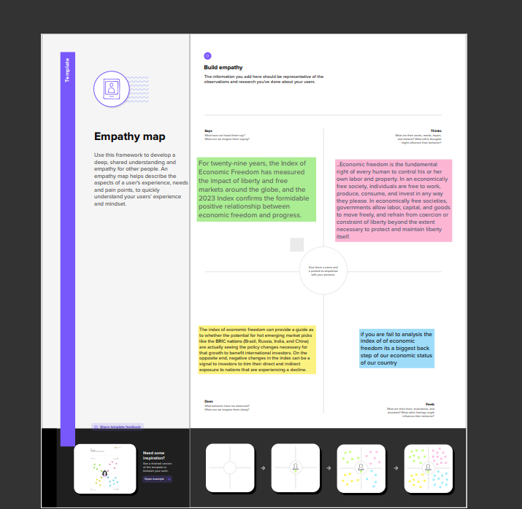

2.2 Ideation & Brainstorming Map:

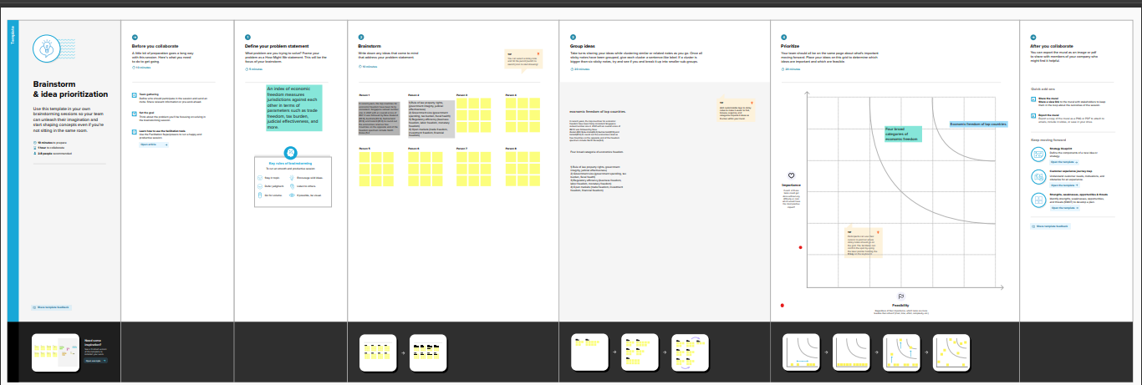

**RESULT**

Dashboard:

1.

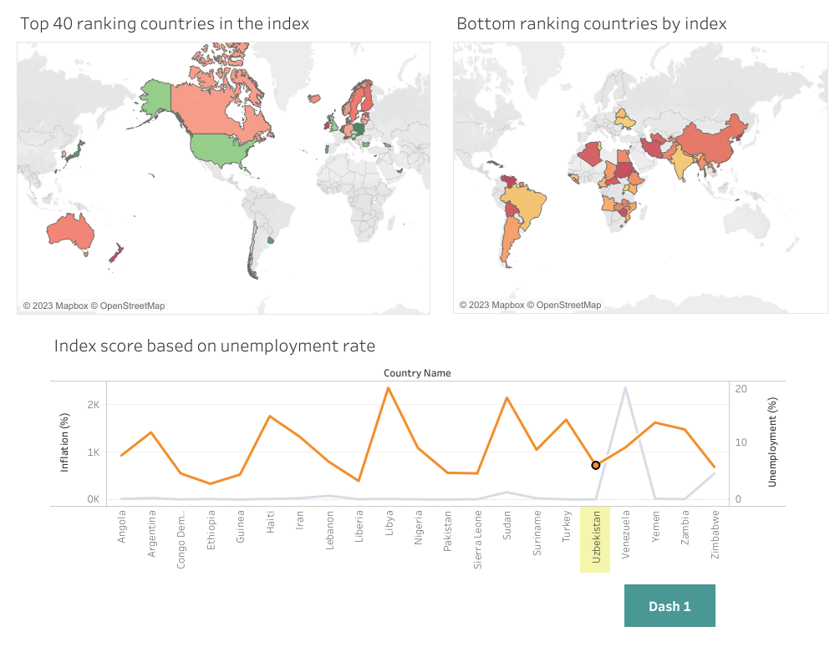

2.

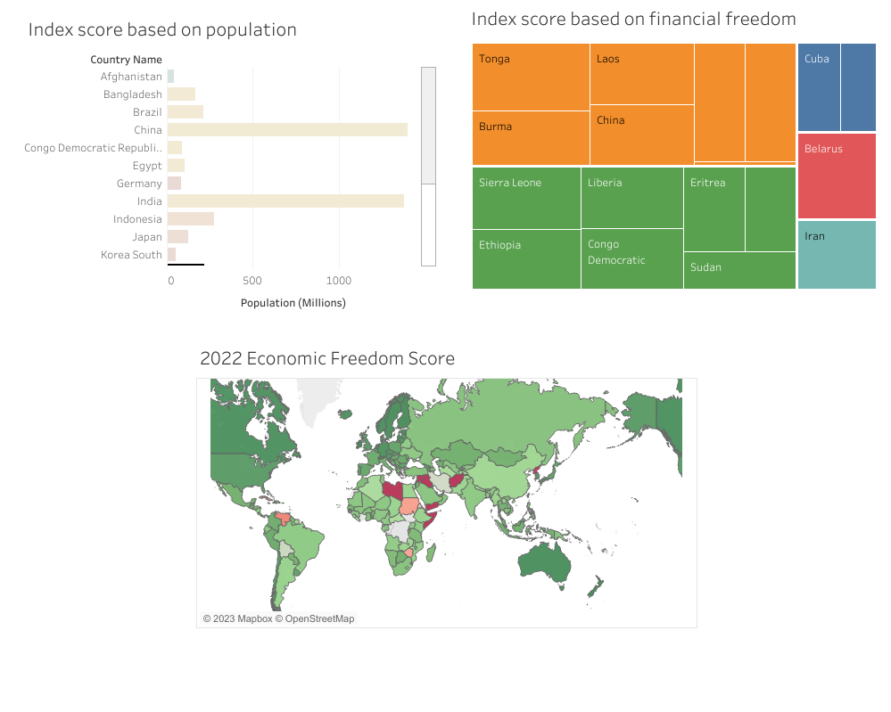

3.

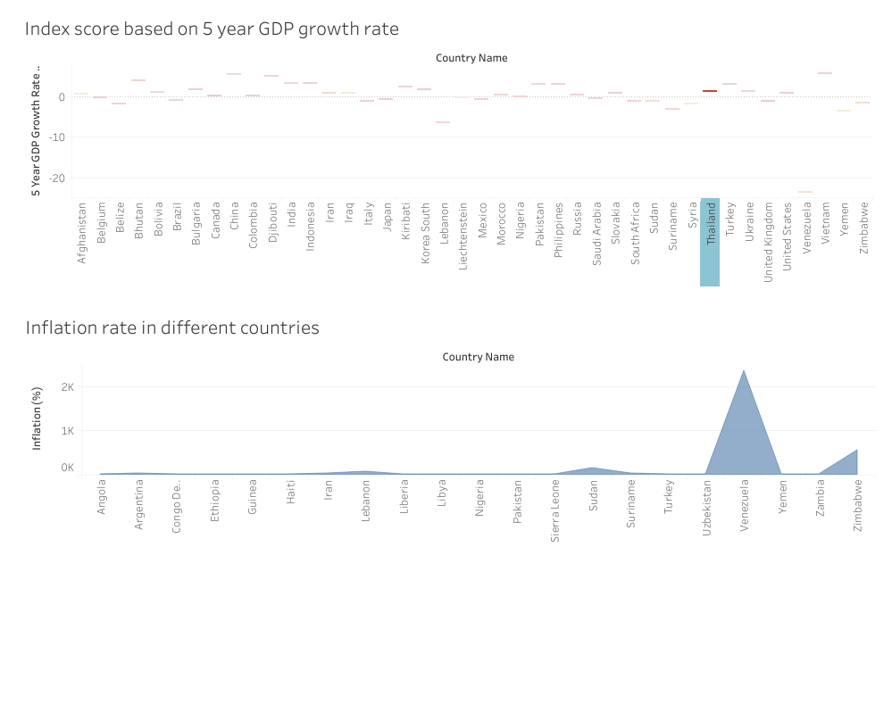

4.

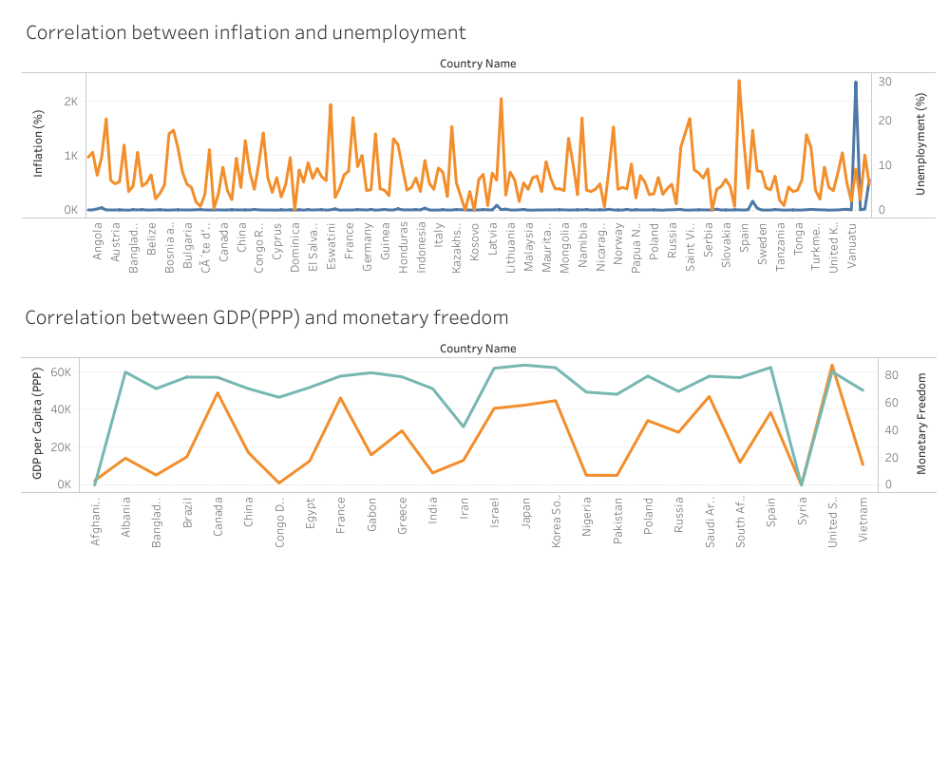

5.

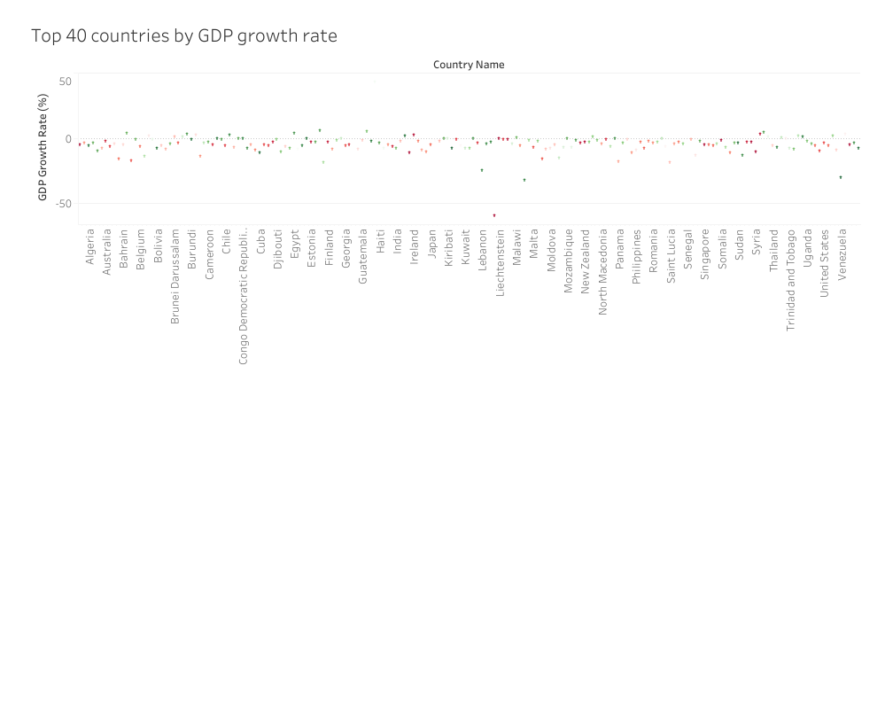

**ADVANTAGES:**

1. Nations with greater economic freedom have stronger economies, with higher gross domestic product per person.

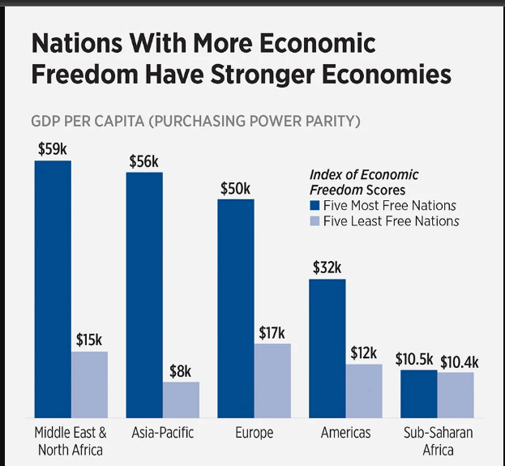

2. Citizens in countries that are economically free enjoy twice as much formal education on average as those in economically repressed nations

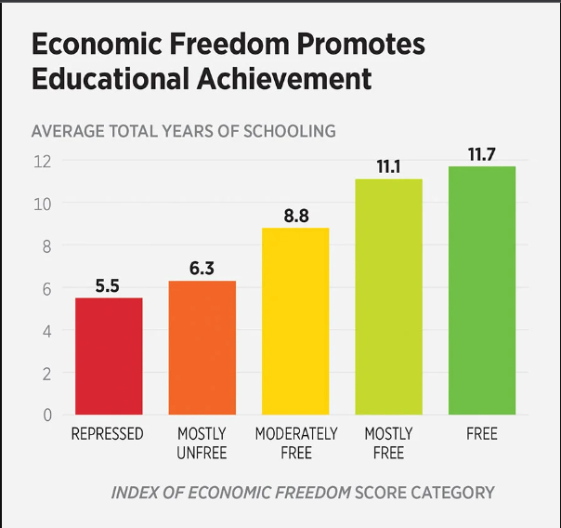

3. Free trade is a key element of economic freedom. Countries that embrace free trade enjoy more prosperity as a result.

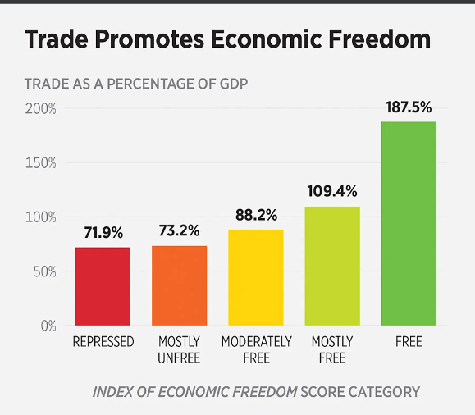

**DISADVANTAGES:**

The index of economic freedom can provide a guide as to whether the potential for hot emerging market picks like the [BRIC nations](https://www.investopedia.com/terms/b/bric.asp) (Brazil, Russia, India, and China) are actually seeing the policy changes necessary for that growth to benefit international investors. On the opposite end, negative changes in the index can be a signal to investors to trim their direct and indirect exposure to nations that are experiencing a decline.

**APPLICATIONS:**

* Tax freedom: measures the importance of fiscal fees imposed by the government on the income of individuals and businesses.
* Government spending: measures the total government spending.
* Free trade: it measures the absence of commercial barriers, affecting the import and export of goods or services.
* Investment freedom: measures the freedom of capital flows.
* Financial freedom: measurement of the independence from the government of credit and banking systems.
* Property rights: they are measures of the ease with which individuals acquire a property of their own.
* Corruption: measures the importance of corruption in the economic world.
* Business undertaking freedom: measures the ease with which it is possible to create, develop and close a business.
* Monetary freedom: measures price stability in relation to a price control.
* Labor Code (This item has been added in 2007. Moreover, in 2017, the Heritage Foundation made some methodological changes; the IEF has 12 components nowadays. The new components are “Judicial Effectiveness” belonging to the Rule of Law pillar and “Fiscal Health” as the new factor of the Government size pillar.): it measures the ease with which workers and companies interact without restriction from the state government.

**CONCLUSION**

To get ahead based on sheer merit and hard work, citizens of any country need a system that maintains nondiscriminatory markets, allocates resources impartially, and rewards individual effort and success. That is the recipe for economic freedom and for the opportunity to build lasting prosperity and real human progress. For much of human history, most individuals have lacked economic freedom and opportunity, condemning them to poverty and deprivation.so we are measuring the economic freedom.

**FUTURE HOPE**

The issue of economic freedom has been a prominence topic in many countries, particularly developing countries like Indonesia. The interest on the issue is not merely related because it is a fundamental right of every individual but also related to its effect on various financial indicators including financial stability (Chortareas et al., [Citation2013](https://www.tandfonline.com/doi/full/10.1080/23311975.2022.2112816); Santoso et al., [Citation2021](https://www.tandfonline.com/doi/full/10.1080/23311975.2022.2112816)). Bavetta ([Citation2004](https://www.tandfonline.com/doi/full/10.1080/23311975.2022.2112816)) defines economic freedom as an individual’s choice to freely carry out economic actions. Economic freedom also means freedom of movement of labor, capital, and goods from various restrictions. Economic freedom in the context of a market economy refers to free competition and voluntary exchange (Gwartney & Lawson, [Citation2002](https://www.tandfonline.com/doi/full/10.1080/23311975.2022.2112816)). Economic freedom underlies the growth and distribution of income (Berggren, [Citation2003](https://www.tandfonline.com/doi/full/10.1080/23311975.2022.2112816)) and high economic growth (De Haan & Sturm, [Citation2000](https://www.tandfonline.com/doi/full/10.1080/23311975.2022.2112816)).

Heritage foundation (2022) defines economic freedom as “the fundamental right of human in controlling its own labor and property in an economically free society where individuals are free to work, produce, consume, and invest in any way they please” also in which “governments allow labor, capital, and goods to move freely, and refrain from coercion or constraint of liberty beyond the extent necessary to protect and maintain liberty itself”. The impact of economic freedom in relation to various economics and financial variables have been interest of researchers. Previous studies have investigated the impact of economic freedom on GDP or economics growth (Doucouliagos & Ulubasoglu, [Citation2006](https://www.tandfonline.com/doi/full/10.1080/23311975.2022.2112816); Nasir & Hassan, [Citation2011](https://www.tandfonline.com/doi/full/10.1080/23311975.2022.2112816); Pambayun, [Citation2021](https://www.tandfonline.com/doi/full/10.1080/23311975.2022.2112816); Seoul & Ramirez, [Citation2019](https://www.tandfonline.com/doi/full/10.1080/23311975.2022.2112816); Uzelac et al., [Citation2020](https://www.tandfonline.com/doi/full/10.1080/23311975.2022.2112816)) on bank performance and bank profitability (Asteriou et al., [Citation2021](https://www.tandfonline.com/doi/full/10.1080/23311975.2022.2112816); Sufian & Habibullah, [Citation2010](https://www.tandfonline.com/doi/full/10.1080/23311975.2022.2112816)), on analysts’ earnings forecast accuracy (T. C. T. Hou & Gao, [Citation2021](https://www.tandfonline.com/doi/full/10.1080/23311975.2022.2112816)), and on renewable energy consumption on CO2 emissions (Shahnazi & Shabani, [Citation2021](https://www.tandfonline.com/doi/full/10.1080/23311975.2022.2112816)). Despite the extensive empirical study on the effect of economic freedom on various financial indicators, its impact on bank stability and risk taking has emerged in the literature in recent years (Ghosh, [Citation2016](https://www.tandfonline.com/doi/full/10.1080/23311975.2022.2112816); Harkati et al., [Citation2020](https://www.tandfonline.com/doi/full/10.1080/23311975.2022.2112816); Sarpong-Kumankoma et al., [Citation2021](https://www.tandfonline.com/doi/full/10.1080/23311975.2022.2112816)). Although these studies focused on cross country data, the findings provide some insights.

**Economic freedom index of Indonesia and the rest of the World *source:***

[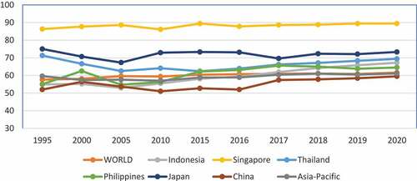](https://www.tandfonline.com/doi/full/10.1080/23311975.2022.2112816)

**APPENDIX**

**Source Code:**

<head>

<meta charset="utf-8" />

<meta name="viewport" content="width=device-width, initial-scale=1, shrink-to-fit=no" />

<!DOCTYPE html>

<meta name="description" content="" />

<meta name="author" content="" />

<title>Economic Freedom Analysis</title>

<link rel="icon" type="image/x-icon" href="assets/favicon.ico" />

<!-- Font Awesome icons (free version)-->

<script src="https://use.fontawesome.com/releases/v6.3.0/js/all.js" crossorigin="anonymous"></script>

<!-- Google fonts-->

<link href="https://fonts.googleapis.com/css?family=Lora:400,700,400italic,700italic" rel="stylesheet" type="text/css" />

<link href="https://fonts.googleapis.com/css?family=Open+Sans:300italic,400italic,600italic,700italic,800italic,400,300,600,700,800" rel="stylesheet" type="text/css" />

<!-- Core theme CSS (includes Bootstrap)-->

<link href="css/styles.css" rel="stylesheet" />

</head>

<body>,

<!-- Navigation-->

<nav class="navbar navbar-expand-lg navbar-light" id="mainNav">

<div class="container px-4 px-lg-5">

<!-- <a class="navbar-brand" href="index.html">Start Bootstrap</a> -->

<button class="navbar-toggler" type="button" data-bs-toggle="collapse" data-bs-target="#navbarResponsive" aria-controls="navbarResponsive" aria-expanded="false" aria-label="Toggle navigation">

Menu

<i class="fas fa-bars"></i>

</button>

<div class="collapse navbar-collapse" id="navbarResponsive">

<ul class="navbar-nav ms-auto py-4 py-lg-0">

<li class="nav-item"><a class="nav-link px-lg-3 py-3 py-lg-4" href="index.html">Home</a></li>

<li class="nav-item"><a class="nav-link px-lg-3 py-3 py-lg-4" href="dashboard_1.html">Dashboard 1</a></li>

<li class="nav-item"><a class="nav-link px-lg-3 py-3 py-lg-4" href="dashboard_2.html">Dashboard 2</a></li>

<li class="nav-item"><a class="nav-link px-lg-3 py-3 py-lg-4" href="dashboard_3.html">Dashboard 3</a></li>

<li class="nav-item"><a class="nav-link px-lg-3 py-3 py-lg-4" href="dashboard_4.html">Dashboard 4</a></li>

<li class="nav-item"><a class="nav-link px-lg-3 py-3 py-lg-4" href="dashboard_5.html">Dashboard 5</a></li>

</ul>

</div>

</div>;

</nav>

<!-- Page Header-->

<header class="masthead" style="background-image: url('assets/img/cover.jpg')">

<div class="container position-relative px-4 px-lg-5">

<div class="row gx-4 gx-lg-5 justify-content-center">

<div class="col-md-10 col-lg-8 col-xl-7">

<div class="site-heading">

<h2 style='color:#ded828'>Economic Freedom Analysis</h2>

<span style='color:#ded828' class="subheading">By Freedom Index</span>

</div>

</div>

</div>

</div>

</header>

<!-- Main Content-->

<div class="container px-4 px-lg-5">

<div class="row gx-4 gx-lg-5 justify-content-center">

<div class='tableauPlaceholder' id='viz1680289060992' style='position: relative'><noscript><a href='#'><img alt='Story 1 ' src='https:&#47;&#47;public.tableau.com&#47;static&#47;images&#47;Bo&#47;Book1_16800806986170&#47;Story1&#47;1_rss.png' style='border: none' /></a></noscript><object class='tableauViz' style='display:none;'><param name='host_url' value='https%3A%2F%2Fpublic.tableau.com%2F' /> <param name='embed_code_version' value='3' /> <param name='site_root' value='' /><param name='name' value='Book1_16800806986170&#47;Story1' /><param name='tabs' value='no' /><param name='toolbar' value='yes' /><param name='static_image' value='https:&#47;&#47;public.tableau.com&#47;static&#47;images&#47;Bo&#47;Book1_16800806986170&#47;Story1&#47;1.png' /> <param name='animate_transition' value='yes' /><param name='display_static_image' value='yes' /><param name='display_spinner' value='yes' /><param name='display_overlay' value='yes' /><param name='display_count' value='yes' /><param name='language' value='en-US' /><param name='filter' value='publish=yes' /></object></div> <script type='text/javascript'> var divElement = document.getElementById('viz1680289060992'); var vizElement = divElement.getElementsByTagName('object')[0]; vizElement.style.width='1016px';vizElement.style.height='991px'; var scriptElement = document.createElement('script'); scriptElement.src = 'https://public.tableau.com/javascripts/api/viz_v1.js'; vizElement.parentNode.insertBefore(scriptElement, vizElement); </script>

</div>

<!-- Divider-->

<hr class="my-4" />

<!-- Pager-->

</div>

</div>

</div>

<!-- Footer-->

<footer class="border-top">

<div class="container px-4 px-lg-5">

<div class="row gx-4 gx-lg-5 justify-content-center">

<div class="col-md-10 col-lg-8 col-xl-7">

<div class="small text-center text-muted fst-italic">Copyright &copy; Your Website 2023</div>

</div>

</div>

</div>

</footer>

<!-- Bootstrap core JS-->

<script src="https://cdn.jsdelivr.net/npm/bootstrap@5.2.3/dist/js/bootstrap.bundle.min.js"></script>

<!-- Core theme JS-->

<script src="js/scripts.js"></script>

</body>

</html>